case1

Problem statement:

Online Shopping Website

Online Shopping Website Create an e-commerce interface displaying products, prices, discounts, ratings, categories, product descriptions, and shopping buttons. Design a responsive product grid, promotional banners, and a shopping navigation bar.

Program code:

<!DOCTYPE html>
<html>
<head>
<title>Smart Shopping Store</title>

<style> body {
font-family: Arial; margin: 0; background: #f5f5f5;
}
header { background: #222; color: white;
text-align: center; padding: 20px;
}
nav {
background: #444; padding: 15px; text-align: center;
}
nav a {
color: white;
text-decoration: none; margin: 10px;
font-weight: bold;
}
h2 {
text-align: center;
}

.banner {
background: orange; text-align: center; padding: 20px;
}
.products { display: grid;
grid-template-columns: repeat(auto-fit, minmax(200px, 1fr)); gap: 20px;
padding: 20px;
}
.card {
background: white; padding: 15px; text-align: center;
border-radius: 10px;
box-shadow: 0 2px 5px #ccc;
}
.card img { width: 100%; height: 200px;
object-fit: contain;
}
.price {
color: green;
font-weight: bold;
}
button {
background: #222; color: white; padding: 10px; border: none; cursor: pointer;
}
footer {
background: #222; color: white;
text-align: center; padding: 10px;
}
</style>
</head>

<body>

<header>
<h1>Smart Shopping Store</h1>
<p>Shop Everything at Best Prices</p>

</header>

<nav>
<a href="#" onclick="showPage('home')">Home</a>
<a href="#" onclick="showPage('men')">Men</a>
<a href="#" onclick="showPage('women')">Women</a>
<a href="#" onclick="showPage('kids')">Kids</a>
<a href="#" onclick="showPage('electronics')">Electronics</a>
<a href="#" onclick="showPage('cart')">Cart</a>
</nav>

<div id="content"></div>

<footer>
<p>Smart Shopping Store | Happy Shopping!</p>
</footer>

<script>
let cart = JSON.parse(localStorage.getItem("cart")) || [];

function showPage(page) {
let content = document.getElementById("content");

if (page == "home") { content.innerHTML = `
<div class="banner">
<h2>Big Shopping Sale!</h2>
<p>Get up to 50% OFF on selected products</p>
</div>
<h2>Welcome to Smart Shopping</h2>
<div class="products">
<div class="card">
<img
src="https://images.unsplash.com/photo-1521572163474-6864f9cf17ab?w=500" alt="T-shirt">
<h3>Fashion Collection</h3>
<p>Explore the latest styles!</p>
</div>
<div class="card">
<img
src="https://images.unsplash.com/photo-1542291026-7eec264c27ff?w=500" alt="Shoes">
<h3>Trending Shoes</h3>
<p>Find your favourite pair!</p>
</div>
</div>`;
}

else if (page == "men") { content.innerHTML = `
<h2>Men's Fashion</h2><div class="products">
${product("Men's T-Shirt","Cotton
T-shirt","https://images.unsplash.com/photo-1521572163474-6864f9cf17ab?w=500", 700)}
${product("Men's Shoes","Casual
shoes","https://images.unsplash.com/photo-1542291026-7eec264c27ff?w=500",1200
)}
${product("Men's Jacket","Stylish
jacket","https://images.unsplash.com/photo-1551028719-00167b16eac5?w=500",150 0)}
</div>`;
}

else if (page == "women") { content.innerHTML = `
<h2>Women's Fashion</h2><div class="products">
${product("Handbag","Stylish
handbag","https://images.unsplash.com/photo-1584917865442-de89df76afd3?w=50 0",1000)}
${product("Women's Shoes","Fashion footwear","https://images.unsplash.com/photo-1543163521-1bf539c55dd2?w=500",1 200)}
${product("Women's Dress","Fashion outfit","https://images.unsplash.com/photo-1490481651871-ab68de25d43d?w=500", 1500)}
</div>`;
}

else if (page == "kids") { content.innerHTML = `
<h2>Kids Shopping</h2><div class="products">
${product("Kids Clothes","Comfortable outfit","https://images.unsplash.com/photo-1519238263530-99bdd11df2ea?w=500",5 00)}
${product("Kids Shoes","Everyday
shoes","https://images.unsplash.com/photo-1514989940723-e8e51635b782?w=500"
,600)}
${product("Teddy Bear","Cute soft
toy","https://images.unsplash.com/photo-1559454403-b8fb88521f11?w=500",400)}
</div>`;
}

else if (page == "electronics") { content.innerHTML = `
<h2>Electronics</h2><div class="products">

${product("Headphones","Clear
sound","https://images.unsplash.com/photo-1505740420928-5e560c06d30e?w=500"
,1400)}
${product("Smart Watch","Modern
watch","https://images.unsplash.com/photo-1523275335684-37898b6baf30?w=500", 1800)}
${product("Camera","Capture your moments","https://images.unsplash.com/photo-1516035069371-29a1b244cc32?w=5 00",2500)}
</div>`;
}

else if (page == "cart") { let total = 0;
let items = "";

cart.forEach(function(item, index) { total += item.price;
items += `<div class="card">
<h3>${item.name}</h3>
<p class="price">₹${item.price}</p>
<button onclick="removeCart(${index})">Remove</button>
</div>`;
});

content.innerHTML = `
<h2>My Shopping Cart</h2>
<div class="products">${items || "<p>Your cart is empty.</p>"}</div>
<h2>Total: ₹${total}</h2>`;
}
}

function product(name, description, photo, price) { return `
<div class="card">
<img src="𝑝ℎ𝑜𝑡𝑜"𝑎𝑙𝑡 = "{name}">
<h3>${name}</h3>
<p>${description}</p>
<p> 4.5/5</p>
<p><del>₹${price + 300}</del></p>
<p class="price">₹${price}</p>
<p>Special Discount!</p>
<button onclick="addCart('𝑛𝑎𝑚𝑒',{price})">Add to Cart</button>
</div>`;
}

function addCart(name, price) { cart.push({name: name, price: price});

localStorage.setItem("cart", JSON.stringify(cart)); alert(name + " added to cart!");
}

function removeCart(index) { cart.splice(index, 1);
localStorage.setItem("cart", JSON.stringify(cart)); showPage("cart");
}

showPage("home");
</script>

</body>
</html>

output
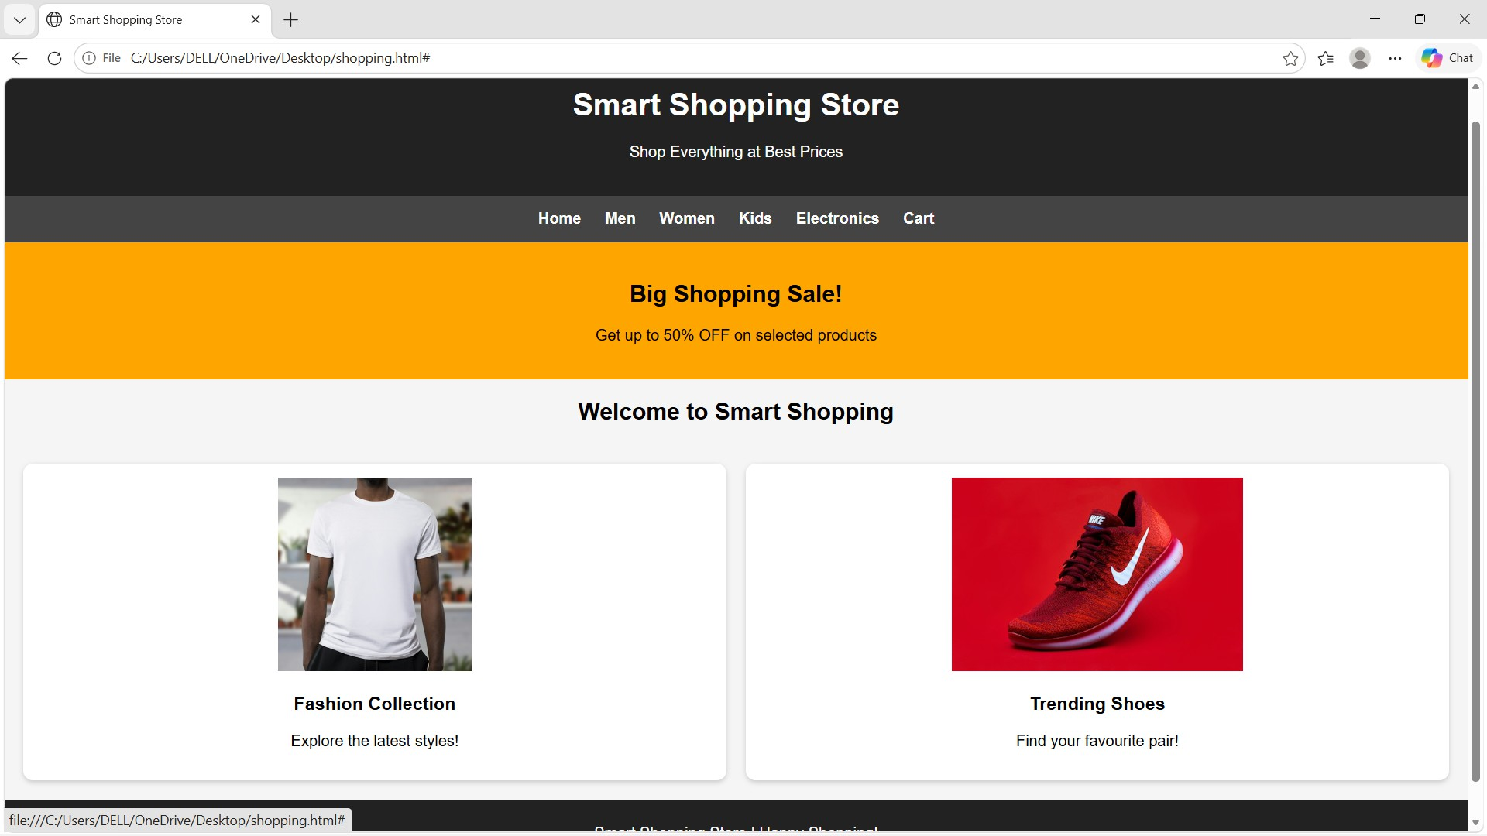
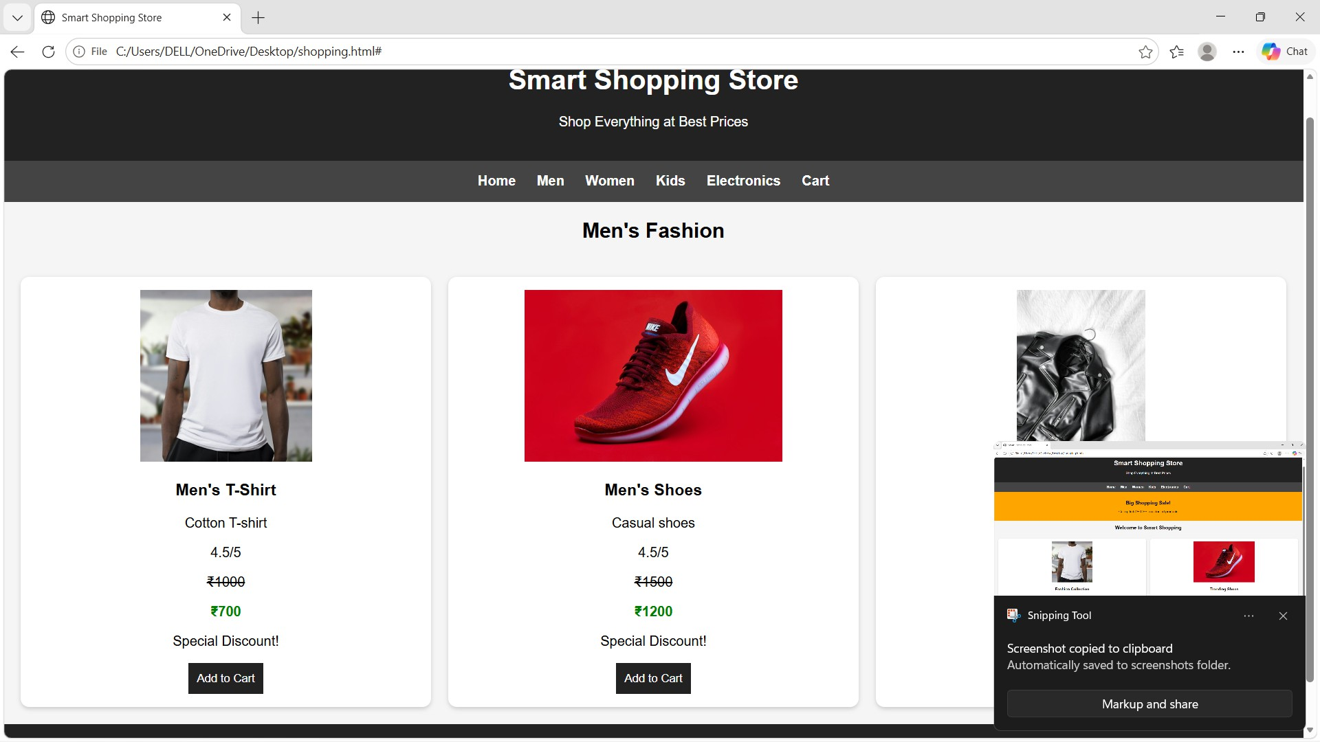

v @smartShopping>tore X + CJ X
E- 0 0 File CjUsers/DELUOneDrive/Desktop/shopping.html# Ochal

Smart Shopping Store

Shop Everything at Best Prices

Home Men Women Kids Electronrcs Cart

Kids Shopping

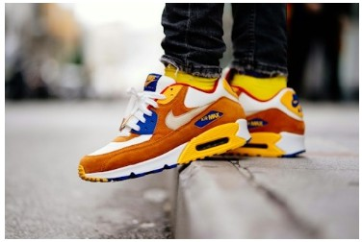
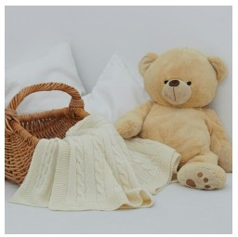
Kids Clothes Kids Shoes Teddy Bear

Comfortable outfii 4.515
<BOO
fSOO
Special Discount!

Everyday shoes 4.515
<900
f600
Special Discount!

Cute soft toy 4.515
�
f400
Special Discoont!

v @smartShopping>lore X + CJ X
E- 0 0 File CjUsers/DELUOneDrive/Desktop/shopping.html# Ochal

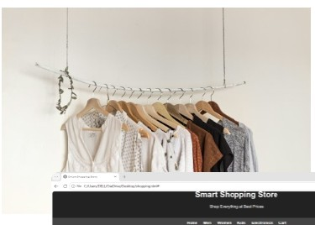
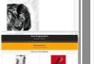
Smart Shopping Store
!)
-
I
>
Screenshot copied to clipboard
Smppinglool

Shop Everything at Best Prices

Home Men Women Kids Electronrcs Cart

Women's Fashion

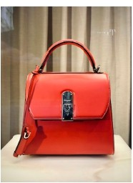
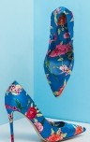
Handbag Stylish handbag 4.515
Women's Shoes Fashion footwear 4.515

f1000 f1200
Special Discount! Special Discount!

Autnrr<'ll r<'lllv �<'lVP<1 tn �rrPPn�hnt� fnk1Pr

lv'arkupandsharc

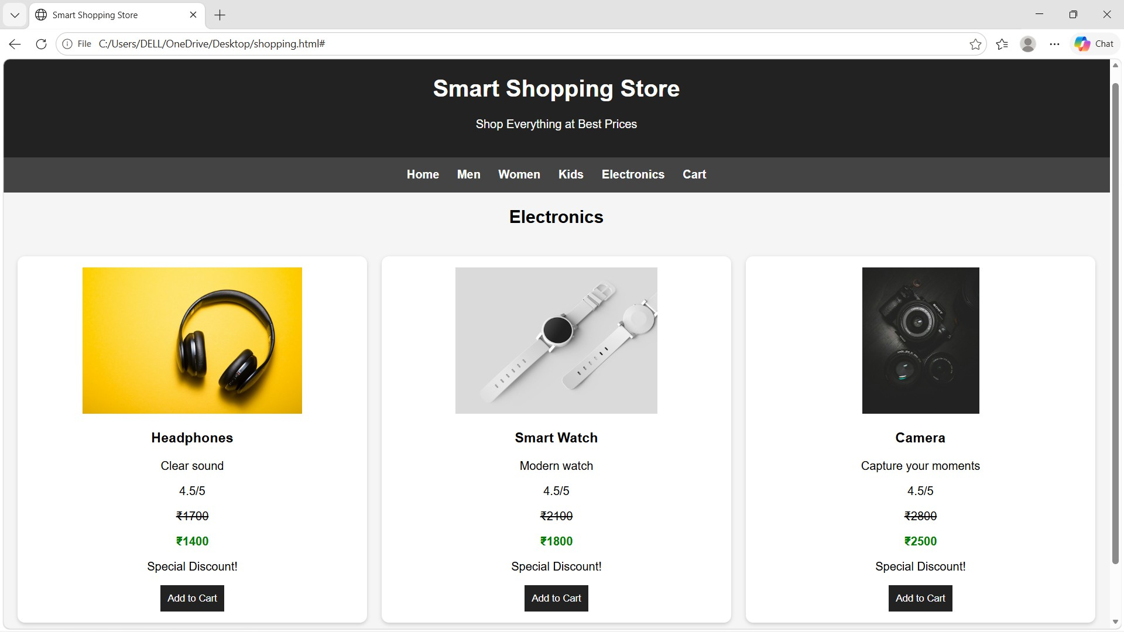
CASE2

Problem statement:

Bakery and Cake Shop Website

Create a website for a bakery displaying cakes, pastries, cookies, custom cake designs, product prices, seasonal offers, and store contact details. Use a visually appealing color scheme and image galleries.

Program code:

<!DOCTYPE html>
<html>
<head>
<title>Sweet Bakery</title>

<style>
body {
font-family: Arial; margin: 0; background: #fff0f5;
}

header {
background: #a8325e;

color: white;
text-align: center; padding: 20px;
}

nav {
background: pink; padding: 15px; text-align: center;
}

nav a {
margin: 10px;
text-decoration: none; color: #702040;
font-weight: bold;
}

h2 {
text-align: center; color: #a8325e;
}

.products { display: grid;
grid-template-columns: repeat(auto-fit, minmax(200px, 1fr)); gap: 20px;
padding: 20px;
}

.card {
background: white; padding: 15px; text-align: center;
border-radius: 10px;
}

.card img { width: 100%; height: 180px;
object-fit: cover; border-radius: 10px;
}

button {
background: #a8325e; color: white;
padding: 10px;

border: none; cursor: pointer;
}

footer {
background: #a8325e; color: white;
text-align: center; padding: 10px;
}
</style>
</head>

<body>

<header>
<h1>Sweet Bakery</h1>
<p>Fresh Cakes, Pastries and Cookies</p>
</header>

<nav>
<a href="#" onclick="showPage('home')">Home</a>
<a href="#" onclick="showPage('cakes')">Cakes</a>
<a href="#" onclick="showPage('pastries')">Pastries</a>
<a href="#" onclick="showPage('cookies')">Cookies</a>
<a href="#" onclick="showPage('custom')">Custom Cakes</a>
<a href="#" onclick="showPage('offers')">Offers</a>
<a href="#" onclick="showPage('contact')">Contact</a>
</nav>

<div id="content"></div>

<footer>
<p>Sweet Bakery | Freshness in Every Bite!</p>
</footer>

<script>
function showPage(page) {
let content = document.getElementById("content");

if (page == "home") { content.innerHTML = `
<h2>Welcome to Sweet Bakery</h2>
<div class="products">
<div class="card">
<img src="https://placehold.co/300x180?text=Delicious+Cakes">
<h3>Delicious Cakes</h3>
<p>Fresh and tasty cakes for everyone!</p>

</div>
<div class="card">
<img src="https://placehold.co/300x180?text=Fresh+Pastries">
<h3>Fresh Pastries</h3>
<p>Enjoy our delicious pastries.</p>
</div>
</div>`;
}

else if (page == "cakes") { content.innerHTML = `
<h2>Our Cakes</h2>
<div class="products">
<div class="card">
<img src="https://placehold.co/300x180?text=Chocolate+Cake">
<h3>Chocolate Cake</h3>
<p>Price: ₹500</p>
</div>
<div class="card">
<img src="https://placehold.co/300x180?text=Strawberry+Cake">
<h3>Strawberry Cake</h3>
<p>Price: ₹600</p>
</div>
</div>`;
}

else if (page == "pastries") { content.innerHTML = `
<h2>Our Pastries</h2>
<div class="products">
<div class="card">
<img src="https://placehold.co/300x180?text=Chocolate+Pastry">
<h3>Chocolate Pastry</h3>
<p>Price: ₹80</p>
</div>
<div class="card">
<img src="https://placehold.co/300x180?text=Vanilla+Pastry">
<h3>Vanilla Pastry</h3>
<p>Price: ₹70</p>
</div>
</div>`;
}

else if (page == "cookies") { content.innerHTML = `
<h2>Our Cookies</h2>
<div class="products">
<div class="card">

<img src="https://placehold.co/300x180?text=Chocolate+Cookies">
<h3>Chocolate Cookies</h3>
<p>Price: ₹150 per pack</p>
</div>
<div class="card">
<img src="https://placehold.co/300x180?text=Butter+Cookies">
<h3>Butter Cookies</h3>
<p>Price: ₹120 per pack</p>
</div>
</div>`;
}

else if (page == "custom") { content.innerHTML = `
<h2>Custom Cake Designs</h2>
<div class="products">
<div class="card">
<img src="https://placehold.co/300x180?text=Birthday+Cake">
<h3>Birthday Cake</h3>
<p>Price: ₹800 onwards</p>
</div>
<div class="card">
<img src="https://placehold.co/300x180?text=Wedding+Cake">
<h3>Wedding Cake</h3>
<p>Price: ₹2000 onwards</p>
</div>
</div>`;
}

else if (page == "offers") { content.innerHTML = `
<h2>Special Offers</h2>
<div class="products">
<div class="card">
<h3>Festival Offer</h3>
<p>Get 10% OFF on selected cakes!</p>
</div>
<div class="card">
<h3>Birthday Offer</h3>
<p>Enjoy special birthday cake offers!</p>
</div>
</div>`;
}

else if (page == "contact") { content.innerHTML = `
<h2>Contact Us</h2>
<div class="card">

<p>Address: Main Road, Vijayawada</p>
<p>Phone: 9876543210</p>
<p>Email: sweetbakery@gmail.com</p>
<p>Opening Hours: 9 AM to 9 PM</p>
</div>`;
}
}

showPage('home');
</script>

</body>
</html>

output:
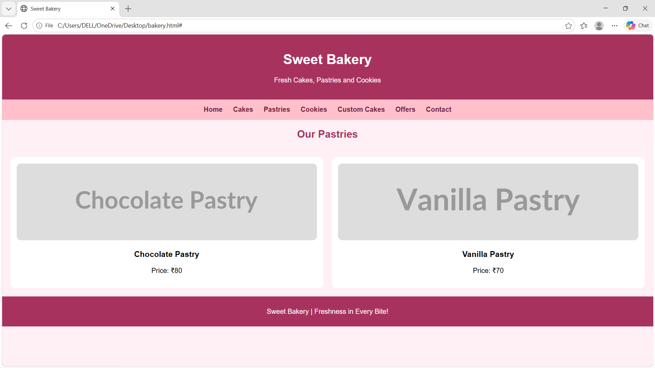
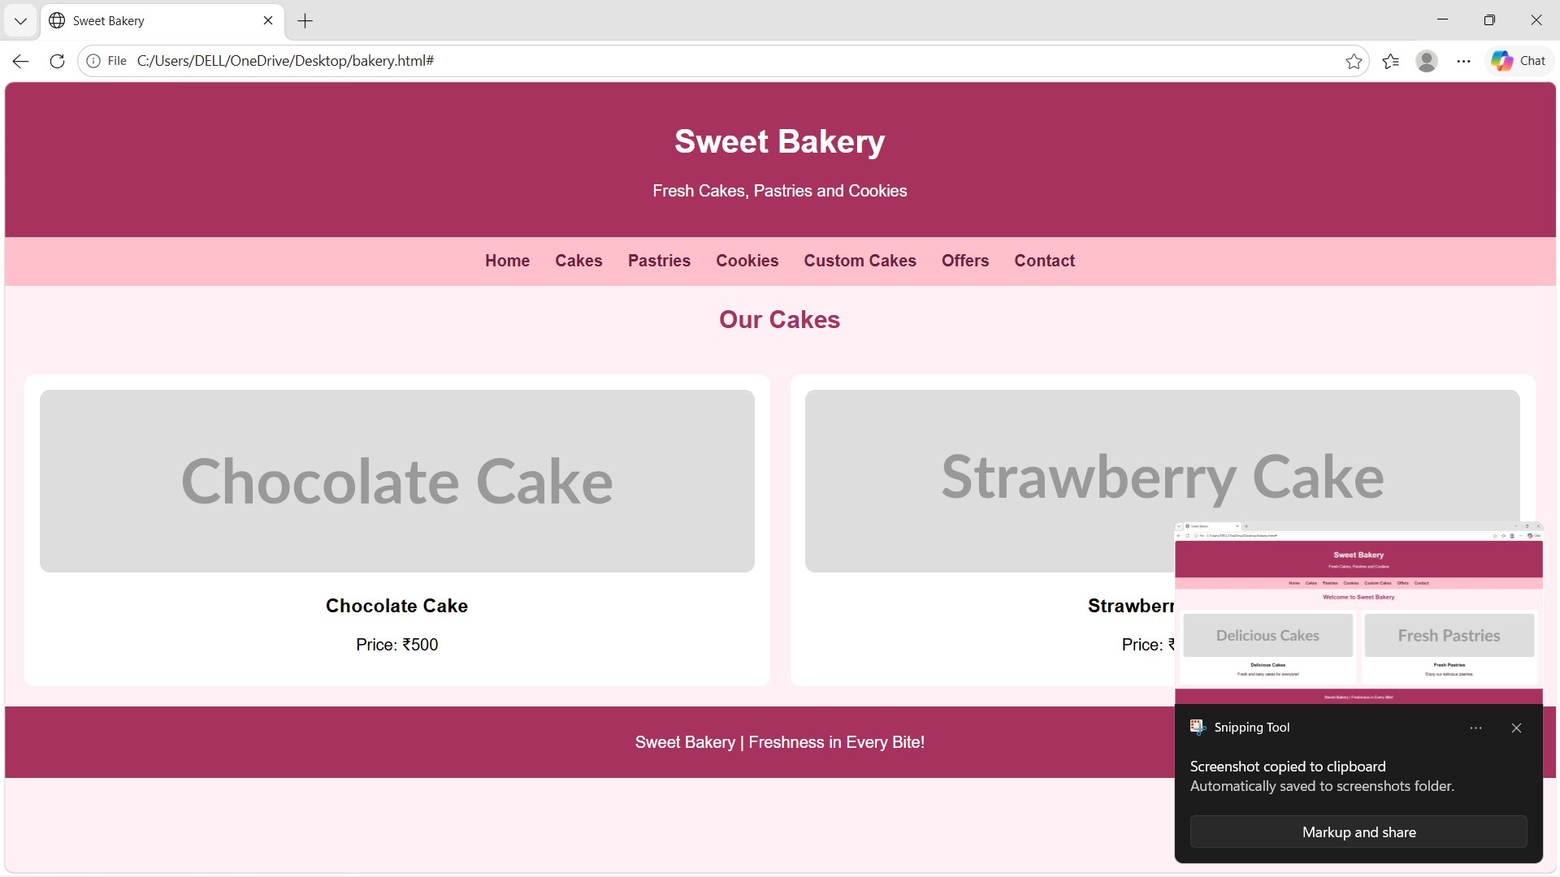

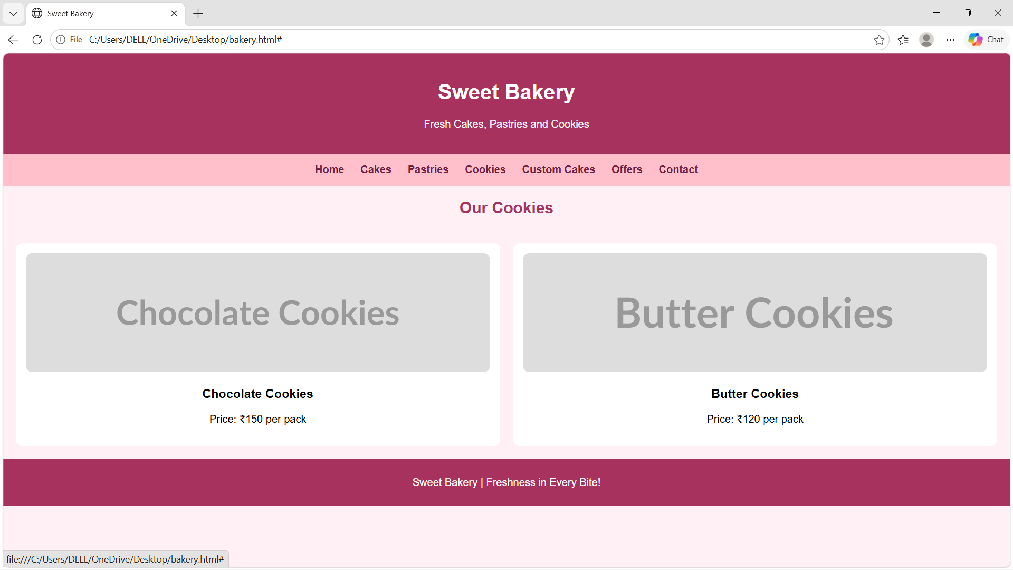
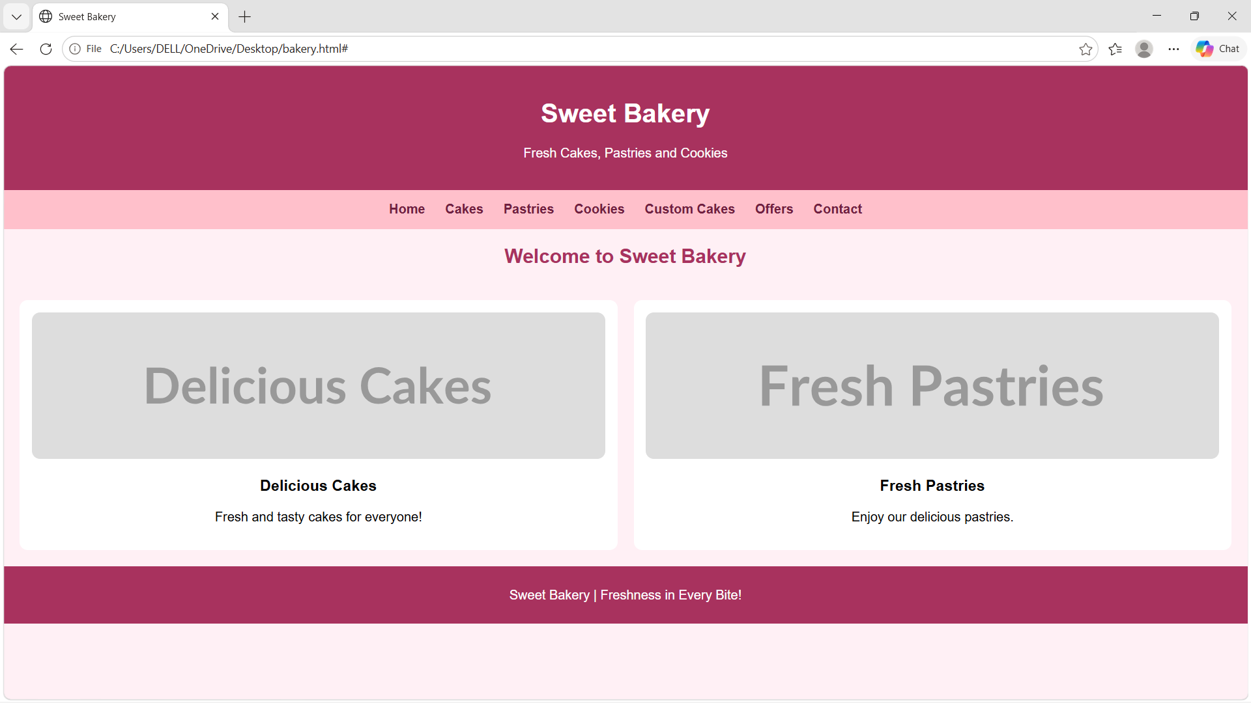
CASE3

Problem statement:

Movie Review and Rating Website

Create a movie website featuring film posters, genres, release dates, cast information, synopsis, critic reviews, and rating displays. Use responsive grids and visually appealing movie cards

Program code:

<!DOCTYPE html>
<html>
<head>
<title>Movie Website</title>
<style>
body {
background: #222; color: white;
text-align: center; font-family: Arial;
}

.movie {
display: inline-block; margin: 15px;
}

img {
width: 180px; height: 250px; border-radius: 10px;
}
</style>
</head>
<body>

<h1>🎬 Movie Reviews</h1>

<div class="movie">
<img src="https://image.tmdb.org/t/p/w500/8Gxv8gSFCU0XGDykEGv7zR1n2ua.jpg">
<h3>Oppenheimer</h3>
⭐ 8.3/10
</div>

<div class="movie">
<img src="https://image.tmdb.org/t/p/w500/1pdfLvkbY9ohJlCjQH2CZjjYVvJ.jpg">
<h3>Avatar</h3>
⭐ 7.9/10
</div>

<div class="movie">

<img src="https://image.tmdb.org/t/p/w500/q6y0Go1tsGEsmtFryDOJo3dEmqu.jpg">
<h3>The Shawshank Redemption</h3>
⭐ 9.3/10
</div>

<div class="movie">
<img src="https://image.tmdb.org/t/p/w500/8Y43POKjjKDGI9MH89NW0NAzzp8.jpg">
<h3>Free Guy</h3>
⭐ 7.1/10
</div>

</body>
</html>

output:
